H.T No
Regulations:
A15

Sreenidhi Institute of Science and Technology
(An Autonomous Institution)
Code No: 5BC03 Date: 28-Mar-2023 (AN)

B.Tech I-Year II- Semester External Examination, March/April-2023 (Supplementary)
ENGINEERING MECHANICS (CIVIL and ME)

Time: 3 Hours Max.Marks:75 Note: a) No additional answer sheets will be provided.
b) All sub-parts of a question must be answered at one place only, otherwise it will not be valued.
c) Missing data can be assumed suitably.

Bloom's Cognitive Levels of Learning (BCLL)
Remember | L1 | Apply | L3 | Evaluate | L5
Understand | L2 | Analyze | L4 | Create | L6

Part - A Max.Marks:25

Answer all QUESTIONS.
 |  | BCLL | CO(s) | Marks
1 | State Parallelogram law of forces. | L1 | CO1 | [2M]
2 | What is meant by a ‘Truss’? | L2 | CO2 | [2M]
3 | State Pappus-Guldinus Theorem. | L1 | CO3 | [2M]
4 | Define the term ‘Product of Inertia’. | L2 | CO4 | [2M]
5 | What is a Moment of Momentum? | L1 | CO5 | [2M]
6 | Explain about Normal and Tangential Components of Curvilinear Motion. | L2 | CO6 | [3M]
7 | Explain the term ‘Resolution of forces’. | L2 | CO2 | [3M]
8 | Differentiate Rolling Friction from Sliding Friction. | L4 | CO4 | [3M]
9 | Differentiate between kinetics and kinematics. | L4 | CO5 | [3M]
10 | Define Work. | L1 | CO1 | [3M]

Part – B Max.Marks:50
ANSWER ANY FIVE QUESTIONS. EACH QUESTION CARRIES 10 MARKS.

 |  |  | BCLL | CO(s) | Marks
11. |  | A system of four forces acting on a body is as shown in Fig.11. Determine the resultant.  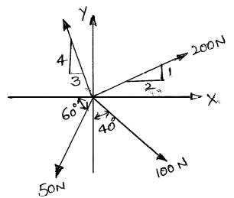Fig.11 | L5 | CO1 | [10M]
12. |  | Analyze the truss shown in fig.12  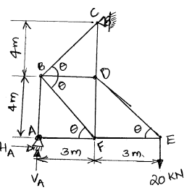Fig.12 | L5 | CO2 | [10M]
13. |  | Determine the centriod of the shaded area shown in fig. 13. which is bounded by the X-axis , the line x=a and the parabola y²= kx.  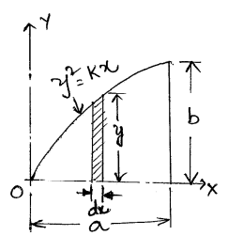Fig.13 | L5 | CO3 | [10M]
14. |  | Determine the moment of inertia of the area shown in fig. 14with respect to its centroidal axes.  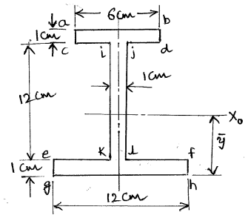Fig.14 | L5 | CO4 | [10M]
15. | a) | Car A at a gasoline station stays there for 10 min after a car B passes at an average speed of 40 mph.How long will take car A moving at an average speed of 50 mph to overtake car B. | L3 | CO5 | [5M]
 | b) | A block weighing 1 kN rests on a horizontal plane as shown in fig. Find the magnitude of the force P required to give the block an acceleration of 3 m/sec² to the right. The coefficient of friction between the block and the plane is 0.25.  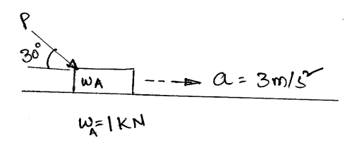 fig-15 | L3 | CO5 | [5M]
16. |  | A bullet weighing 0.3 N is fired horizontally into a body weighing 100N which is suspended by a string 0.8m long. Due to this impact the body swings through an angle of 30º. Find the velocity of the bullet and the loss in the energy of the system.  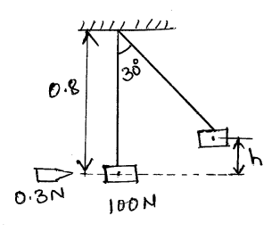 fig-16 | L4 | CO6 | [10M]
17. |  | Three forces acting at a point are shown in fig.17. The direction of the 300N forces may vary, but the angle between them is always 40. Determine the value of for which the resultant of the three forces is directed  parallel to b-b.  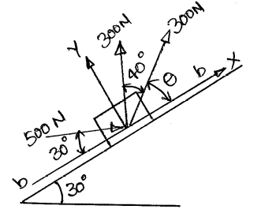fig-17 | L5 | CO1 | [10M]
18. | a) | Discuss the equation of motions under gravity. | L4 | CO4 | [5M]
 | b) | Differentiate liner and angular momentum. | L3 | CO5 | [5M]

-- 00 -- 00 –

